**DROPLET

This document was adopted by UNC Health Care for its use in infection control. It is provided for your information only.

PRECAUTIONS

*PRECAUCIONES DE TRANSMISIÓN POR GOTAS*

Perform hand hygiene

*Llevar a cabo la higiene de manos.*

*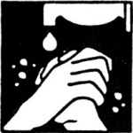*

Surgical mask while in room

*Utilizar mascarilla quirúrgica en la habitación.*

**

**

Families and Guests

*Familias y visitantes*

* Clean hands upon entering and exiting room
* *Lavarse las manos al entrar y al salir de la habitación.*
* Wear a surgical mask while in the room and remove upon exiting.
* *Utilizar mascarilla quirúrgica en la habitación y quitársela al salir.*



*Translated by UNC Health Care Interpreter Services, 04/14/15*