Attachment 1: Quick Glance to Identify Patients who Need Contact Precautions for Multidrug-resistant organisms (MDRO) in Psychiatric Services
Flagged for MDRO infection?
Place patient in private room
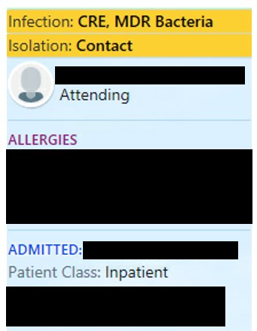
Does the patient:
- have an open wound that cannot be covered with a clean dressing, OR
- have a tracheostomy and cannot perform respiratory hygiene?
YES
NO
Use Contact Precautions:

- Order Precautions
- Place blue sign on the door
- Place isolation cart outside of room
- Educate patient about Contact Precautions, and document education
Contact Infection Prevention at 984-974-7500 for questions
Contact Precautions not necessary:

- Educate patient on hand hygiene
- If patient has wound, cover with a dressing

