Minutes | Monday, November 2 | Presenter
8:00 | Welcome | Marty Cooney
8:15 | Environmental Guidelines | Bill Rutala
9:30 | Break
9:45 | High-Level Disinfection, Sterilization, and Antisepsis | Bill Rutala
11:00 | Break
11:15 | High-Level Disinfection, Sterilization, and Antisepsis – (cont.) | Bill Rutala
12:30 | Lunch
1:30 | Vendor Visits | Atrium
2:30 | Construction & Renovation: Water Loss and Mold Remediation | Marty Cooney
3:30 | Break
3:45 | Infections in the Immunocompromised Host | Elizabeth (Eli) Arant
4:45 | Dismiss

 | Tuesday, November 3
8:00 | Infection Control in the Pharmacy | Chris Falato
9:00 | Break
9:15 | Plant Engineering | Bill Rutala
9:55 | Break
10:10 | Indications & Methods for Microbiologic Sampling  of the Hospital Environment | Bill Rutala
11:00 | Break
11:15 | Central Processing
11:55 | Lunch | Bill Rutala
12:55 | IC in Community-Based Practices and Ambulatory Care Centers | Angela Warren
1:55 | Break
2:10 | Environmental Services: Practical Tips | Marty Cooney
3:10 | Infection Control in the Movies | David Weber
4:10 | Dismiss

 | Wednesday, November 4
8:00 | Management of Antibiotic-Resistant Pathogens | Zachary Willis
9:00 | Break
9:15 | Animals in the Hospital: Infection Control Considerations | Sarah Rhea
10:00 | Break
10:15 | Best Practices for Surface Disinfection and Medical Waste | Bill Rutala
11:15 | Lunch
12:15 | Disinfection and Sterilization: Current Issues, New Research, New Technologies | Bill Rutala
1:15 | Break
1:30 | Disaster Planning | Jeffrey Hammerstein
2:45 | Break
3:00 | Safe Injection Practices | Marty Cooney
4:00 | Dismiss

 | Thursday November 5
8:00 | Biothreats | David Wohl
9:00 | Break
9:15 | Pandemic Planning: Focus on Emerging Pathogens | Brooke Brewer
10:15 | Break
10:30 | DPH Outbreak Workshop | Emily Berns, Catie Bryan
12:00 | Lunch
1:00 | Nutritional Services | Marty Cooney
2:00 | General Q&A / Discussion | Marty Cooney
3:00 | Dismiss

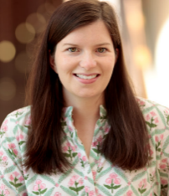
Dr. Elizabeth (Eli) Arant, MD, MSCR
Dr. Arant is an Assistant Professor of Medicine in the UNC School of Medicine. She specializes in treating and preventing infections in patients with solid organ transplants, stem cell transplants, hematologic malignancies, and burns. She also provides general HIV care at the Wake County Department of Health. Her research focuses on outcomes of solid organ transplantation in people with HIV, as well as increasing access to transplant for people with HIV.

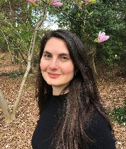
Emily Berns, MPH, RN
Emily is an Infection Prevention Nurse Consultant with the Communicable Disease Branch within the North Carolina Division of Public Health, assisting with Group A Strep and MDRO public health responses. She received her MPH from the UNC Gillings School of Global Public Health and her BSN from the University of Miami. She worked as an acute care nurse before entering the field of public health.
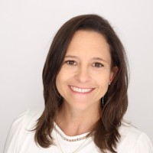
Brooke Brewer, BSN, RN, MS, CIC
Brooke is a Program Manager in the Infection Prevention Department at UNC Health. She is responsible for high-consequence pathogen preparedness and response, as well as the Program Manager for UNC’s new Regional Emerging Special Pathogen Treatment Center program. She has been an RN with UNC Health for over 16 years.

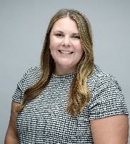
Catherine Bryan, MPH, a-IPC
Catie is currently a Healthcare-associated epidemiologist at the North Carolina Division of Public Health, Communicable Diseases Branch. She received a Bachelor of Science in Health Science at Marshall University and then a Master of Public Health at the University of Louisville. During her time as a student, Catie worked at UofL’s Division of Infectious Diseases as a student assistant. After graduation, Catie worked at a county health department in West Virginia as a COVID-19 Epidemiologist. Before her current role, Catie was a CDC/CSTE Fellow at the Texas Department of State Health Services, Health Care Safety Investigations Unit and obtained her Associate - Infection Prevention and Control Certification in 2023.

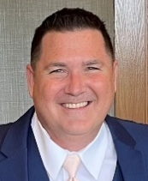
Dr. Marty Cooney, DrPH, MPH, ME, BSN, RN, CIC
Dr. Cooney is the SPICE Associate Director. His previous position was the Director of Infection Control at UNC Rex Healthcare for 14 years. Prior to his work at UNC Rex, Dr. Cooney was the Director of Infection Control and Employee Health at HMA/Novant Healthcare. His clinical nursing experience prior to infection control included roles as an interventional radiology nurse, ER and OR nurse, medical-surgical nurse, and bed control.
Dr. Cooney received his Doctor of Public Health from UNC Chapel Hill in 2023. He completed his Master of Public Health at the University of New England in 2018, and Master of Entrepreneurship in 2011. Dr. Cooney also received a Bachelor of Science Nursing in 2007 and is also a CIC. He has delivered several presentations at professional conferences and published in infection prevention journals.

Dr. Chris Falato, Pharm. D.
Dr. Falato is the Assistant Director of Pharmacy for Pediatrics at UNC Children’s Hospital. He earned his Doctor of Pharmacy degree from Duquesne University, where he developed a strong commitment to advancing care for pediatric patients. Dr. Falato furthered his expertise through residency training at Texas Children’s Hospital, where he focused on the specialized needs of this unique patient group. Following several years as a clinical pharmacist, Dr. Falato transitioned into an administrative role at Johns Hopkins Children’s Hospital. In 2014, he joined UNC Children’s Hospital as the Clinical Manager for the Pediatric Pharmacy. In this capacity, he has brought a wealth of experience in quality and safety initiatives to the institution. Dr. Falato has played a pivotal role in designing and constructing new pharmacy facilities tailored to enhance the distribution of medication for pediatric patients. His work integrates Lean and Quality principles to optimize both layout and workflow, ensuring the highest standards of efficiency and safety in pharmaceutical care.

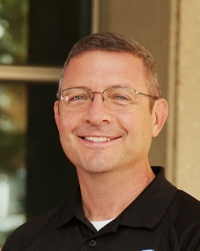
Jeffrey Hammerstein
Jeffrey Hammerstein retired as an assistant chief after 33 years with Wake County EMS in Raleigh, NC. He worked as a paramedic, field training officer, district supervisor, public information officer, and head of EMS community outreach. He has presented at multiple local, state, and national EMS-related conferences. He has worked for the last four years as an Emergency Preparedness Coordinator with UNC Rex Hospital in Raleigh, NC. He lives with his wife in Garner, NC.

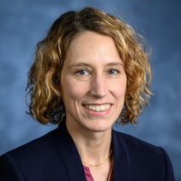
Dr. Sarah Rhea, DVM, MPH, PhD
Dr. Rhea is an Assistant Professor in the Department of Population Health and Pathobiology at North Carolina State University. Dr. Rhea’s expertise is in epidemiology and global public health. Her research interests, informed by her clinical training and experience in public health practice, encompass topics in infectious disease and environmental epidemiology. Dr. Rhea’s research program focuses on identifying drivers of disease in human and animal populations and to inform interventions to reduce disease burden.

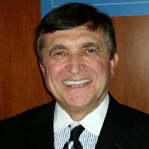
Dr. William A. Rutala, PhD, MPH
Dr. Rutala is a Professor of Medicine in the Division of Infectious Diseases at the University of North Carolina's School of Medicine. He serves as the Director and co-founder of the Statewide Program for Infection Control and Epidemiology at the UNC School of Medicine. In 2017, after 38 years, Dr. Rutala retired from his position as the Director of Hospital Epidemiology, Occupational Health, and Safety Program at the University of North Carolina Hospitals. He has more than 700 publications (peer-reviewed articles, books, book chapters, brief reports) in the fields of disinfection and sterilization, including several guidelines (e.g., CDC Guideline for Disinfection and Sterilization in Healthcare Facilities) and the epidemiology and prevention of healthcare-associated infections. Dr. Rutala earned his Bachelor of Science degree in science from Rutgers University, his master's degree in microbiology from the University of Tennessee, and both his master's in public health and doctorate in microbiology from the University of North Carolina School of Public Health. He is certified in Infection control and a retired Colonel in the United States Army Reserve.

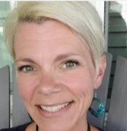
Angela Warren, RN, BSN, MS, CIC
Angela has a bachelor’s degree in nursing from the University of Southern Maine, as well as her master’s degree in Infection Prevention and Epidemiology from the University of Providence. Most of her nursing career, Angela worked in the Emergency Department, and she has spent the last ten years working as an Infection Preventionist. She is a member of several professional organizations, such as The Society for Healthcare Epidemiology of America (SHEA), the Association for Professionals in Infection Control and Epidemiology (APIC), and the North Carolina Association for Professionals in Infection Control (NC-APIC). She is currently serving as an NC-APIC Zone Coordinator. She is a Registered Nurse with National Board Certification in Infection Control. Angela worked with SPICE as an Infection Prevention Consultant, where she developed educational tools, presented educational sessions, and consulted with various facilities regarding their Infection Control Programs.

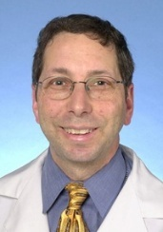
Dr. David J. Weber, MD, MPH, FIDSA, FSHEA, FRCM (London)
Dr. Weber has been on the faculty of the University of North Carolina at Chapel Hill since 1985 where he is currently a Professor of Medicine and Pediatrics in the School of Medicine, and a Professor of Epidemiology in the School of Public Health. Dr. Weber serves as the Medical Director for NC SPICE. Dr. Weber serves as the Associate Chief Medical Officer for UNC Hospitals and the Department of Hospital Epidemiology (Infection Prevention and Control). He is Board Certified in Internal Medicine, Infectious Disease, Critical Care Medicine, and Preventive Medicine. He serves as an Associate Editor of Infection Control and Hospital Epidemiology. His research interests include healthcare-associated infections, new and emerging pathogens (such as norovirus, SARS-CoV, CA-MRSA, and Pfiesteria, infections in childcare centers, and antibiotic-resistant pathogens.

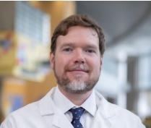
Dr. Zachary Willis, MD, MPH
Dr. Willis is the Director of the Pediatric Antimicrobial Stewardship Program at UNC Health and is an Associate Professor of Pediatric Infectious Disease at UNC School of Medicine. Dr. Willis completed a pediatric residency and fellowship in pediatric infectious diseases before joining the faculty of the UNC Department of Pediatrics in 2016. In his role as an antimicrobial steward, Dr. Willis closely follows the epidemiology of highly drug-resistant organisms and current evidence-based strategies for optimal treatment. He has recently served as a faculty member in the North Carolina Clinical Partners in Antimicrobial Stewardship program, providing antimicrobial stewardship education to healthcare providers across the state.


Dr. David Wohl, MD
Dr. Wohl is a Professor of Medicine in the Division of Infectious Diseases at the University of North Carolina (UNC). He is co-Principal Investigator of the Global UNC Infectious Diseases Clinical Trials Unit and Site Leader of its Chapel Hill research site. Dr. Wohl is a clinical scientist with a focus on emergent infectious diseases. He has spent over 20 years leading research into the prevention and treatment of HIV and served two terms as a member of the US Department of Health and Human Services (DHHS) Antiretroviral Guidelines Panel. Since 2014, he has been working continuously in Liberia, West Africa, conducting research with Ebola survivors to learn about chronic complications and sexual transmission of this infection and establishing the UNC Project Liberia research platform at two locations in the country. He and his team have extended this work to examine Lassa fever, a viral hemorrhagic fever endemic in West Africa. In 2020, he helped lead the UNC clinical and research response to COVID-19. He is the Medical Director of a large drive-through testing site, as well as two COVID-19 vaccination clinics. He serves as Vice Chair of ACTIV-2, an international AIDS Clinical Trials Group (ACTG)/Operation Warp Speed trial of SARS-CoV-2 therapeutics. Additionally, he has an active cli[nical practice at UNC.

